Documentación

Justification for Data Selection
We selected this dataset because we were interested in gaining a clear understanding of who the primary actors in road traffic accidents are and identifying the patterns associated with traffic incidents in Colombia. This understanding allows us to propose data-driven solutions to address these issues.
The analysis was conducted using the R programming language, leveraging several statistical and data visualization libraries to generate accurate inferences regarding the road users most exposed to traffic accidents.
Data Cleaning
To ensure that the analysis focused on the main actors involved in traffic accidents, we removed records in which the “victim characteristic” corresponded to pedestrians, passengers, motorcycle passengers, vehicle passengers, external passengers, or missing data. This decision was made because the objective of the study is to identify patterns among drivers, specifically cyclists, motorcyclists, and automobile drivers.
Additionally, in order to identify accident patterns by day of the week, we corrected inconsistencies in the spelling of weekday names within the dataset. This standardization was necessary to avoid significant discrepancies that could distort the analysis.
Furthermore, cases lacking information—such as third or fourth vehicles involved—were removed. Variables such as accident time and district location were also excluded, as they were not relevant to the objectives of this analysis.
As a result of this data cleaning process, we obtained a more refined and focused dataset, enabling more accurate inferences regarding the types of road users most exposed to fatal traffic accidents.

Gender vs. Victim Classification
Out of a total of 280 victims, 247 were men and 33 were women.
Among men, the majority of fatalities correspond to motorcycle drivers (201 cases), followed by cyclists (34) and automobile drivers (12).
Among women, the most affected group is also motorcycle drivers (31 cases), with only isolated cases involving cyclists (2).
These results confirm that motorcycle riding represents the highest road safety risk for both genders. However, the volume of male cases is significantly higher, indicating a strong gender disparity in traffic-related fatalities.
Age vs. Victim Classification
Overall, these findings reaffirm that the highest probability of fatality in traffic accidents is concentrated among young adults, particularly motorcyclists, and to a lesser extent, cyclists. The positive skewness of the age distribution highlights the need to direct road safety prevention campaigns primarily toward these groups.


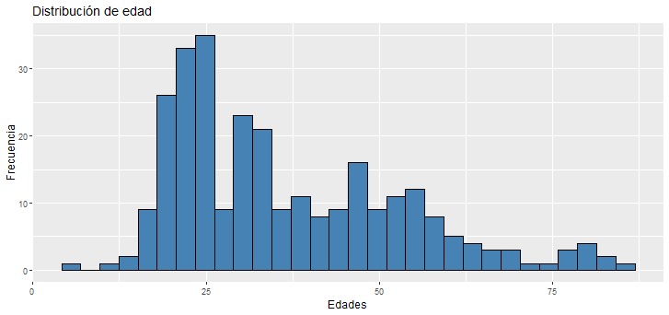

This chart illustrates the age distribution of individuals involved in traffic accidents using a histogram. It allows for the identification of the most common age ranges as well as the overall shape of the distribution.
Normality Test Using Shapiro–Wilk
The Shapiro–Wilk test is used to assess whether the distribution of the Age variable follows a normal distribution.


Since the p-value is 3.164e-11, the null hypothesis of normality is rejected.
Subsequently, we focused on creating summary tables to analyze the distribution of accidents by gender and accident type, including proportions and confidence intervals.
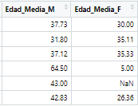

Age Distribution by Accident Type and Gender
This boxplot visualizes the dispersion of ages across each accident category, disaggregated by gender. It is useful for identifying medians, quartiles, and potential outliers, allowing for a comparative analysis of age patterns across accident types and genders.

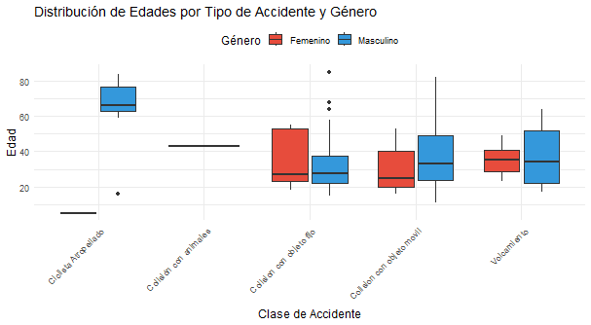

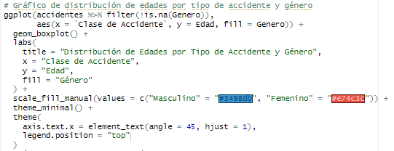
Accidents by Day of the Week
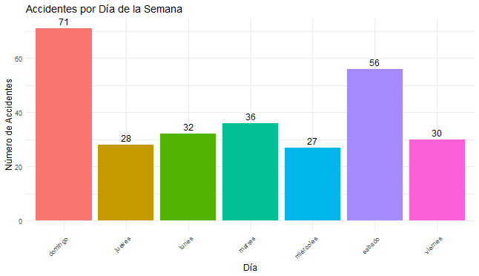
This bar chart displays the total number of accidents for each day of the week, with labels indicating the exact count for each category.

Hypothesis Testing
This section presents the analysis of several hypotheses using statistical tests, allowing for inferences about the relationships between different variables. For all tests, a 95% confidence level and a significance level of 0.05 are assumed.
Proportion Tests (prop.test)
Hypothesis: Are fewer than 20% of those involved in accidents women?
This test evaluates whether the proportion of women involved in traffic accidents is significantly lower than 20%.
- Null Hypothesis (H₀): The proportion of women involved in accidents is greater than or equal to 20% (p ≥ 0.20).
- Alternative Hypothesis (H₁): The proportion of women involved in accidents is less than 20% (p < 0.20).
If the p-value is less than 0.05, the null hypothesis is rejected.
The obtained p-value is 0.0003875; therefore, the null hypothesis is rejected. This result provides statistically significant evidence to conclude that fewer than 20% of individuals involved in traffic accidents are women.

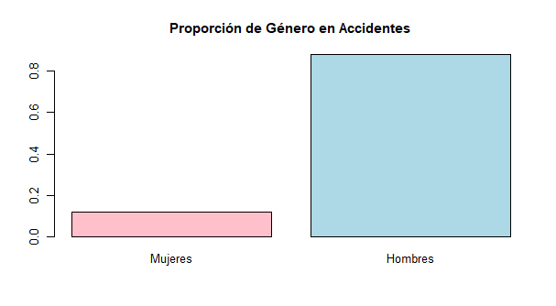
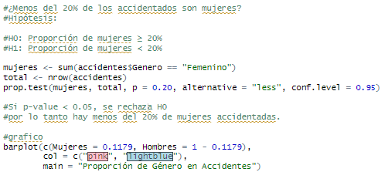
Hypothesis: Do more than 70% of accidents involve motorcyclists?
This test assesses whether the proportion of traffic accidents involving motorcyclists is significantly greater than 70%.
- Null Hypothesis (H₀): The proportion of accidents involving motorcyclists is less than or equal to 70% (p ≤ 0.70).
- Alternative Hypothesis (H₁): The proportion of accidents involving motorcyclists is greater than 70% (p > 0.70).
If the p-value is less than 0.05, the null hypothesis is rejected.
The obtained p-value is 1.832e-06; therefore, the null hypothesis is rejected. This result indicates statistically significant evidence to conclude that more than 70% of traffic accidents involve motorcyclists.

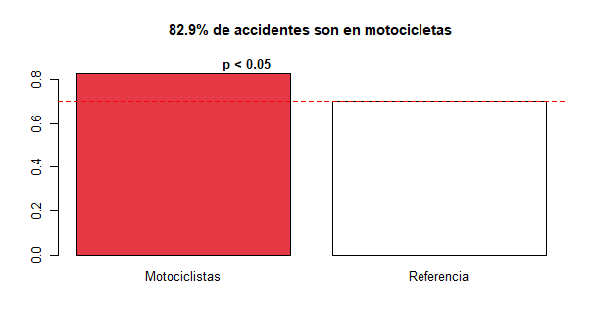
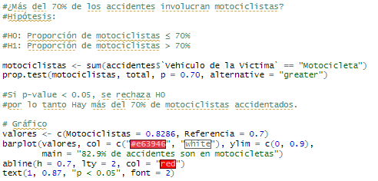

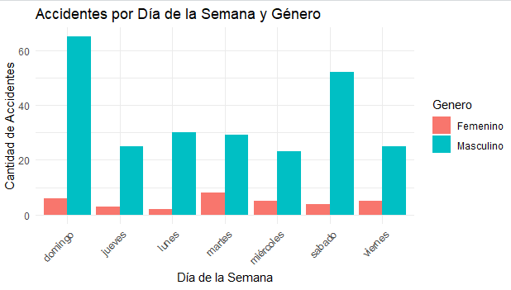
Hypothesis: Association Between Day of the Week and Gender
- Null Hypothesis (H₀): There is no association between the day of the week and gender.
- Alternative Hypothesis (H₁): There is an association between the day of the week and gender.
A chi-square test of independence was conducted to evaluate this relationship. Based on the results, the null hypothesis was not rejected, indicating that there is no statistically significant association between the day of the week and gender.
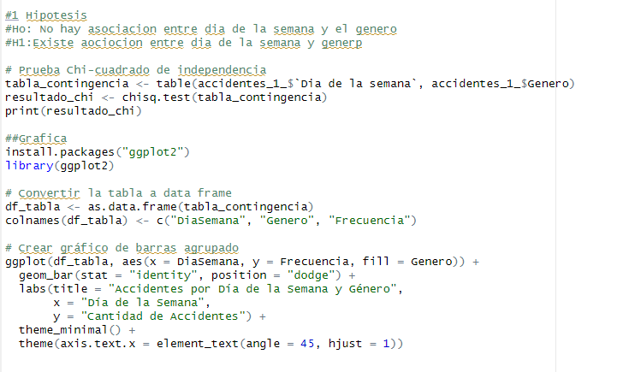
Hypothesis 2: Relationship Between Day of the Week and Accident Type
- Null Hypothesis (H₀): There is no relationship between the day of the week and the type of accident.
- Alternative Hypothesis (H₁): There is a statistically significant relationship between the day of the week and the type of accident.

A chi-square test of independence was conducted, and the null hypothesis was rejected (p = 0.0267), indicating a statistically significant relationship between the day of the week and the type of accident.
The results show that Saturdays are the day most associated with fatalities resulting from collisions with moving objects. On this day, this type of accident also represents a much higher proportion compared to other accident categories. In fact, on Saturdays, collisions with moving objects occurred almost four times more frequently than collisions with fixed objects. In contrast, when analyzing the trend across the remaining days of the week, the proportion between collisions with moving objects and fixed objects appears more balanced.
Collisions with fixed objects are significantly more frequent on Sundays, occurring nearly three times more often than on the second most common day for this type of accident. This pattern raises an important question regarding its underlying causes.

A plausible explanation, while intuitive, is useful for guiding actions aimed at reducing the high number of traffic-related fatalities. In many Colombian cities, traffic restriction policies such as pico y placa do not apply on Saturdays, leading to a substantially higher volume of vehicles on the roads throughout the day. Increased traffic density raises the likelihood of vehicle-to-vehicle collisions, exacerbated by congestion-related stress and a greater tendency for drivers to rush to their destinations. As a result, collisions with moving objects become more frequent.

Regarding collisions with fixed objects, Sundays show a pronounced increase compared to other days, exceeding Saturday by nearly threefold. This trend suggests that such accidents predominantly occur on Sundays, potentially due to increased alcohol or substance consumption during weekend nights, particularly in the early hours of Sunday. Under these conditions, drivers may experience impaired motor skills and reduced concentration, increasing the probability of leaving the roadway or losing control of the vehicle and colliding with fixed objects.
Additionally, it is worth noting that rollover accidents are also more frequent during weekends (Friday, Saturday, and Sunday). This further reinforces the notion that drivers are more likely to lose control of their vehicles on weekends, likely associated with substance use.

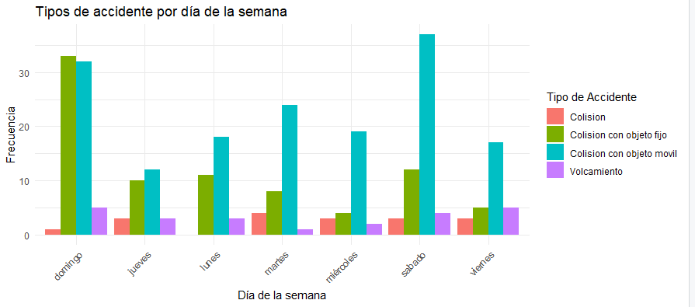
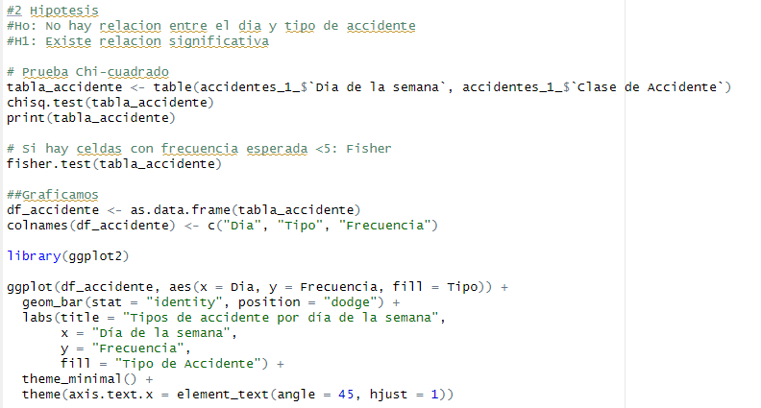

Hypothesis 3: Relationship Between Victim Characteristics and Day of the Week
- Null Hypothesis (H₀): Victim characteristics are independent of the day of the week.
- Alternative Hypothesis (H₁): There is a dependency between victim characteristics and the day of the week.
A chi-square test of independence was performed. Based on the results, the null hypothesis was not rejected, indicating that victim characteristics have no statistically significant relationship with the day on which the accident occurred.

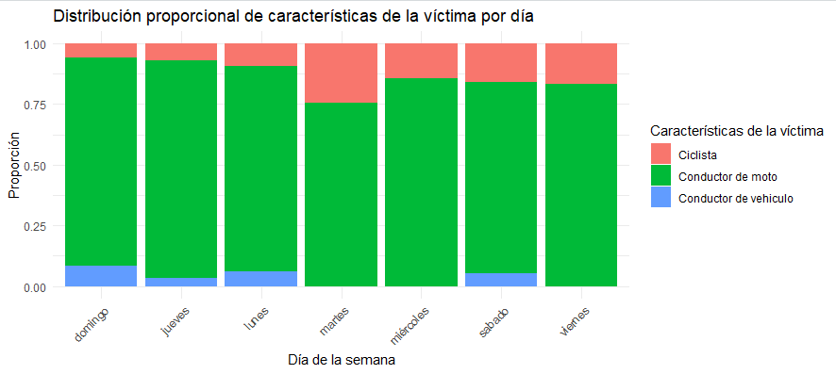
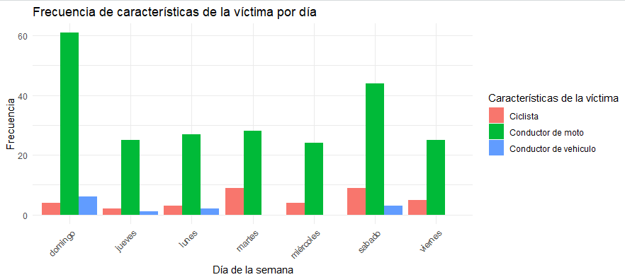

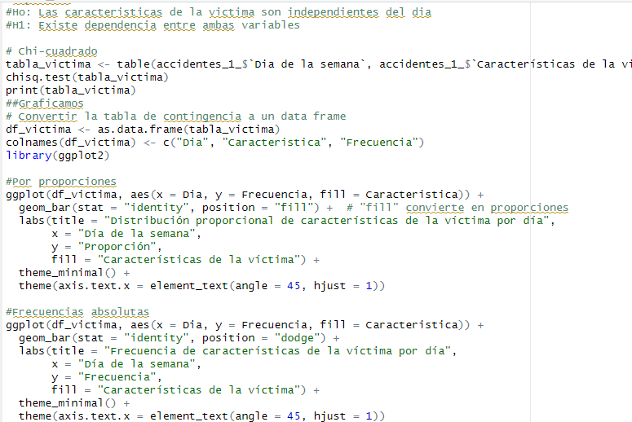

Hypothesis 4: Relationship Between Gender and Accident Type
- Null Hypothesis (H₀): Gender and accident type are independent.
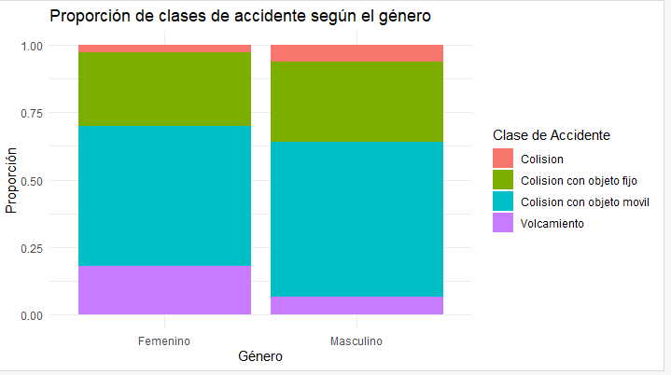
- Alternative Hypothesis (H₁): There is a relationship between gender and accident type.
A chi-square test of independence was conducted. The results indicate that the null hypothesis was not rejected, suggesting that there is no statistically significant relationship between gender and accident type.
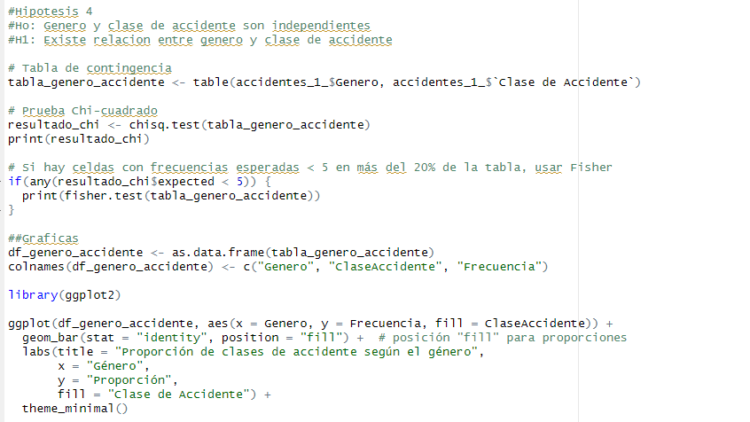

Hypothesis 5: Relationship Between Victim Characteristics and Gender
- Null Hypothesis (H₀): There is no relationship between victim characteristics and gender.
- Alternative Hypothesis (H₁): There is a relationship between victim characteristics and gender.
A chi-square test of independence was performed. The results indicate that the null hypothesis was not rejected, meaning there is no statistically significant evidence to suggest a relationship between victim characteristics and gender.
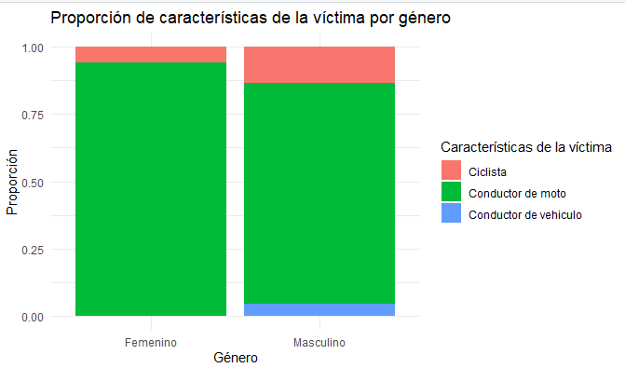
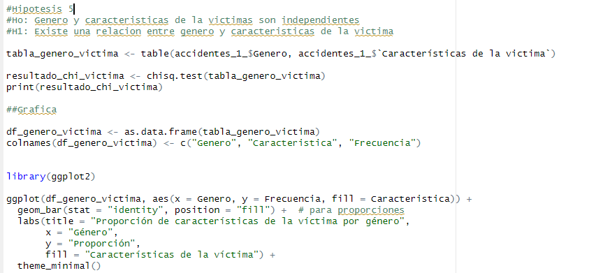

Hypothesis 6: Relationship Between Accident Type and Victim Characteristics
- Null Hypothesis (H₀): There is no relationship between accident type and victim characteristics.
- Alternative Hypothesis (H₁): There is a relationship between accident type and victim characteristics.
A chi-square test of independence was conducted. The null hypothesis was rejected (p = 2.652e-11), indicating a very strong relationship between accident type and victim characteristics.
During data cleaning, certain rows that could distort the chi-square analysis due to having fewer than five values were renamed or consolidated. Examples include “Collision with animals,” “Occupant fall,” “Collision with cyclists,” and some incorrectly labeled collision data. These were grouped under the general category “Collision” to represent incidents where the driver was not primarily at fault, or where sample sizes were too small to analyze separately.
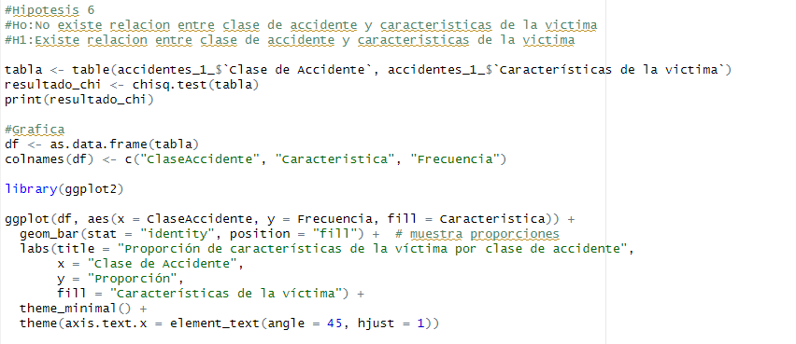
The analysis shows that most of these collisions involved cyclists. This is largely because a significant proportion of cyclist-related accidents are situations in which the cyclist was not at fault, such as being struck by a vehicle. In contrast, cyclists are less involved in accidents where they might collide with a fixed or moving object. Overall, the main risk for cyclists comes from being directly struck on the road rather than from causing collisions themselves.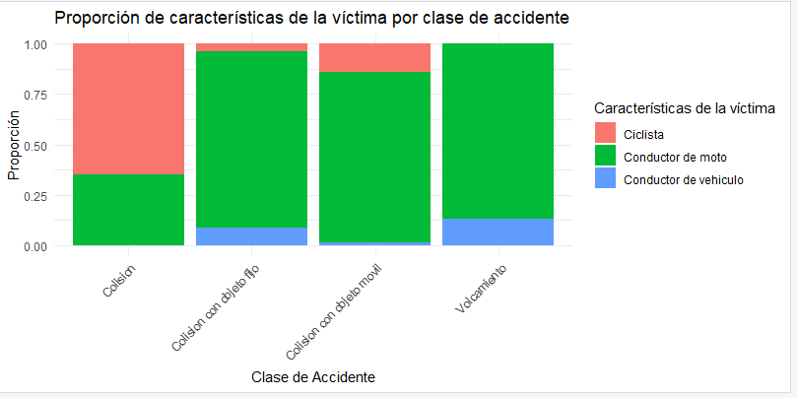

Hypothesis 7: Frequency of Accidents by Day of the Week
- Null Hypothesis (H₀): The frequency of accidents is the same across all days of the week.
- Alternative Hypothesis (H₁): Some days have a higher frequency of accidents than others.
The null hypothesis was rejected (p = 2.167e-07), providing statistically significant evidence that accident frequencies vary by day of the week.
Overall, the highest number of accidents tends to occur on Saturdays and Sundays. This may be due to increased likelihood of drivers being under the influence of alcohol or other substances on weekends, impairing motor and cognitive skills, and thereby significantly increasing the risk of fatal traffic accidents.

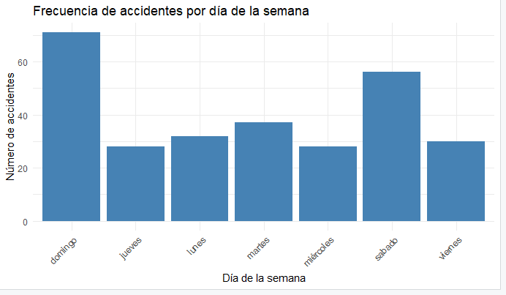

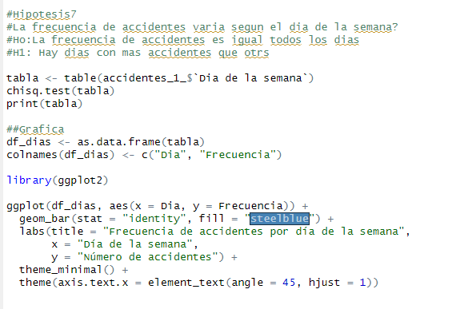

Hypothesis: Does the distribution of “Collision with Fixed Object” vary by gender?
- Null Hypothesis (H₀): The proportion of “Collision with Fixed Object” accidents does not depend on gender.
- Alternative Hypothesis (H₁): The proportion of “Collision with Fixed Object” accidents varies by gender.
If the p-value is less than 0.05, the null hypothesis is rejected.
The obtained p-value is 0.9088, so the null hypothesis is not rejected. This indicates that there is no statistically significant evidence to suggest that the proportion of “Collision with Fixed Object” accidents differs between men and women.

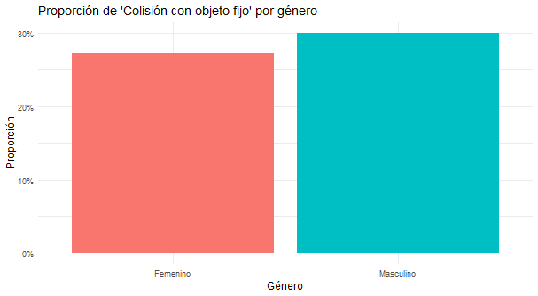

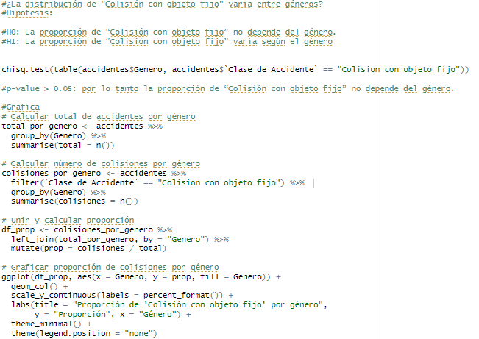

t-Tests for Means (t.test)
These tests evaluate whether there are significant differences in the means of numerical variables between groups.
Hypothesis: Does the average age of accident victims differ by gender?
- Null Hypothesis (H₀): The average age of male accident victims is equal to the average age of female accident victims (μ_Male = μ_Female).
- Alternative Hypothesis (H₁): The average age of male accident victims is different from the average age of female accident victims (μ_Male ≠ μ_Female).
If the p-value is less than 0.05, the null hypothesis is rejected.
The obtained p-value is 0.0391, which leads to rejection of the null hypothesis. This provides statistically significant evidence that the average age of accident victims differs between genders.
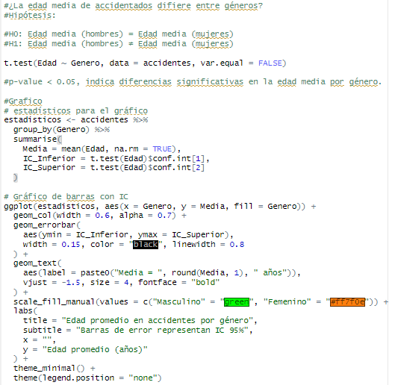
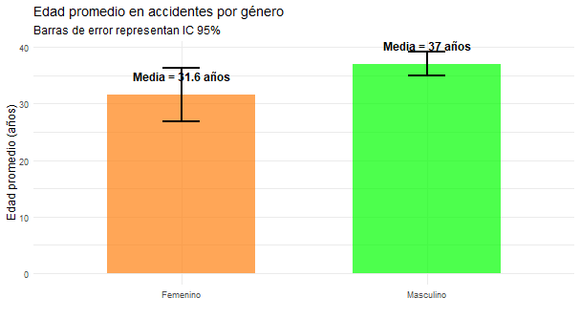
Hypothesis: Is the average age of motorcyclists involved in accidents less than 35 years?
- Null Hypothesis (H₀): The average age of motorcyclists involved in accidents is greater than or equal to 35 years (μ ≥ 35).
- Alternative Hypothesis (H₁): The average age of motorcyclists involved in accidents is less than 35 years (μ < 35).
If the p-value is less than 0.05, the null hypothesis is rejected.
The obtained p-value is 0.01322, leading to rejection of the null hypothesis. This provides statistically significant evidence that the average age of motorcyclists involved in accidents is less than 35 years.

